Project Documemtations

# **Summary Dashboard**

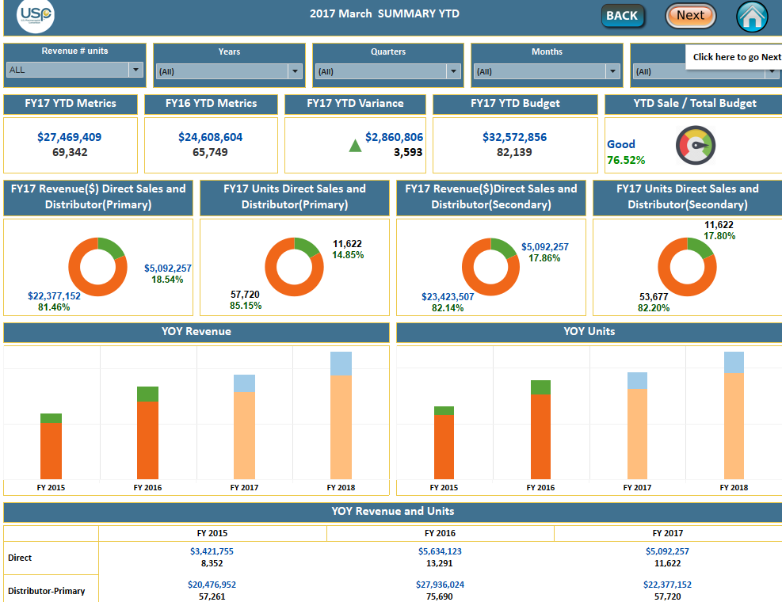

**4J**

* **Data sources** - Primary Data.
* **Buttons** – Home, Next, Back.
* **Filters** – Revenue # Units, Years, Quarters, and Channels.
* **Forecast Analysis**- Revenue, Units.
* **Measures**- Value in USD, Units.
* **Dimensions**-Channel, Date.
* **Calculations** – Current YTD, Previous YTD, YTD Variance, YTD Budget, YTD Sale/Total Budget.
* **Charts**- Donuts, Bars, Text.

**Calculations**

**Current YTD:**

IF [Adjust date] <= [Adjust Fixed Date]

AND DATEDIFF ('year', [Adjust date], [Adjust Fixed Date]) =0

//OR DATEDIFF ('year', [Date], [Calculation1]) =1)

THEN [Value in Usd] END

**Adjust Date:**

DATEADD ('month', 6, [Date])

**Adjust Fixed Date:**

DATEADD ('month', 6, [Fixed date])

**Fixed Date:**

{FIXED: MAX ([Date])}

**Current YTD Units:**

IF [Adjust date] <= [Adjust Fixed Date]

AND DATEDIFF ('year', [Adjust date], [Adjust Fixed Date]) =0

//OR DATEDIFF ('year', [Date], [Calculation1]) =1)

THEN ([Units]) END

**Previous Current YTD:**

IF [Adjust date] <= [Adjust Fixed Date]

AND DATEDIFF ('year', [Adjust date], [Adjust Fixed Date]) =2

AND MONTH ([Adjust date]) <=MONTH ([Adjust Fixed Date])

//OR DATEDIFF ('year', [Date], [Calculation1]) =1)

THEN [Value in Usd] END

**Previous Current YTD Units:**

IF [Adjust date] <= [Adjust Fixed Date]

AND DATEDIFF ('year', [Adjust date], [Adjust Fixed Date]) =2

AND MONTH ([Adjust date]) <=MONTH ([Adjust Fixed Date])

//OR DATEDIFF ('year', [Date], [Calculation1]) =1)

THEN ([Units]) END

**Variance:**

**YTD**

ABS (ZN (RUNNING_SUM (sum ([Current YTD]))) - LOOKUP (ZN (RUNNING_SUM (SUM ([Previous Ytd]))), -1))

**Units**

ABS (ZN (RUNNING_SUM (SUM ([Current YTD (Units)]))) - LOOKUP (ZN (RUNNING_SUM (SUM ([Previous Ytd (Units)]))), -1))

**YTD Budget:**

SUM (IF [Date] <= TODAY () THEN [YTD budget Dollars] end)

**YTD Budget Units:**

SUM (IF [Date] <= TODAY () THEN [YTD budget Units] end)

**YTD Sale / Total Budget:**

If [% of Achievement (primary)] <= 50 then "Poor"

Else if [% of Achievement (primary)]>50 and [% of Achievement (primary)] <=60 then "Average"

Else if [% of Achievement (primary)]>60 then "Good"

END

**% of Achievement (primary):**

(SUM ([Primary DATA]. [Current YTD]))/SUM ([Budget Dollars])* 100

# **Pu summary Dashboard**

**Data sources** - Primary Data.

**Buttons** – Home, Next, Back.

**Filters** – Years, Quarters, Channels.

**Measures**- Value in USD, Units.

**Dimensions**-Channel, Date, Category.

**Calculations** – Current YTD, Previous YTD, YTD Variance, YTD Budget, YTD Sale/Total Budget.

**Charts**- Bars (logarithmic), Text

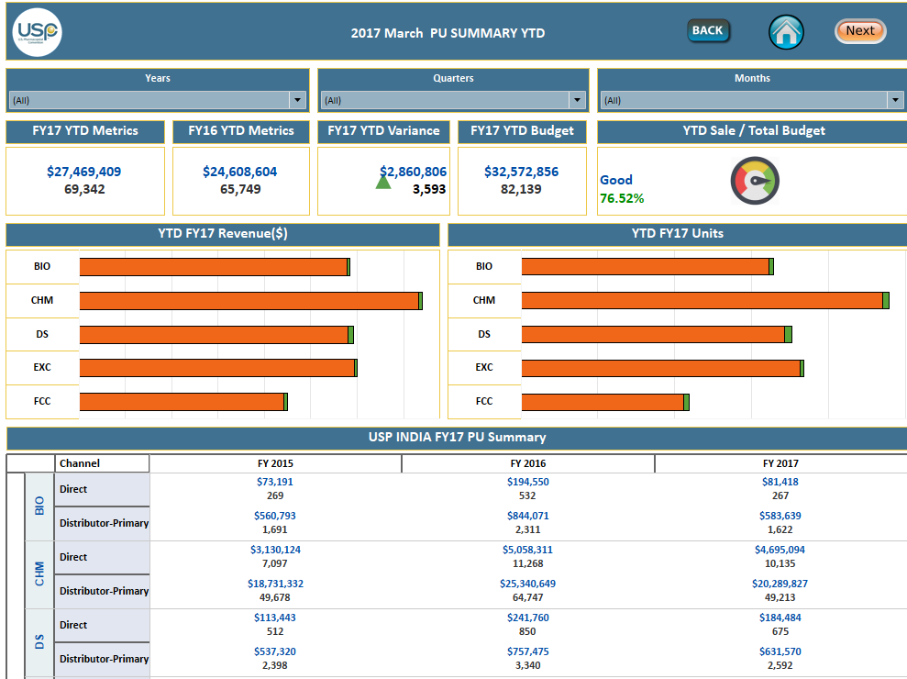

4J

**Calculations**

**Current YTD:**

IF [Adjust date] <= [Adjust Fixed Date]

AND DATEDIFF ('year', [Adjust date], [Adjust Fixed Date]) =0

//OR DATEDIFF ('year', [Date], [Calculation1]) =1)

THEN [Value in Usd] END

**Adjust Date:**

DATEADD ('month', 6, [Date])

**Adjust Fixed Date:**

DATEADD ('month', 6, [Fixed date])

**Fixed Date:**

{FIXED: MAX ([Date])}

**Current YTD Units:**

IF [Adjust date] <= [Adjust Fixed Date]

AND DATEDIFF ('year', [Adjust date], [Adjust Fixed Date]) =0

//OR DATEDIFF ('year', [Date], [Calculation1]) =1)

THEN ([Units]) END

**Previous Current YTD:**

IF [Adjust date] <= [Adjust Fixed Date]

AND DATEDIFF ('year', [Adjust date], [Adjust Fixed Date]) =2

AND MONTH ([Adjust date]) <=MONTH ([Adjust Fixed Date])

//OR DATEDIFF ('year', [Date], [Calculation1]) =1)

THEN [Value in Usd] END

**Previous Current YTD Units:**

IF [Adjust date] <= [Adjust Fixed Date]

AND DATEDIFF ('year', [Adjust date], [Adjust Fixed Date]) =2

AND MONTH ([Adjust date]) <=MONTH ([Adjust Fixed Date])

//OR DATEDIFF ('year', [Date], [Calculation1]) =1)

THEN ([Units]) END

**Variance:**

**YTD**

ABS (ZN (RUNNING_SUM (sum ([Current YTD]))) - LOOKUP (ZN (RUNNING_SUM (SUM ([Previous Ytd]))), -1))

**Units**

ABS (ZN (RUNNING_SUM (SUM ([Current YTD (Units)]))) - LOOKUP (ZN (RUNNING_SUM (SUM ([Previous Ytd (Units)]))), -1))

**YTD Budget:**

SUM (IF [Date] <= TODAY () THEN [YTD budget Dollars] end) **YTD Budget Units:**

SUM (IF [Date] <= TODAY () THEN [YTD budget Units] end)

**YTD Sale / Total Budget:**

If [% of Achievement (primary)] <= 50 then "Poor"

Else if [% of Achievement (primary)]>50 and [% of Achievement (primary)] <=60 then "Average"

Else if [% of Achievement (primary)]>60 then "Good"

END

**% of Achievement (primary):**

(SUM ([Primary DATA]. [Current YTD]))/SUM ([Budget Dollars])* 100

# **Direct and Secondary Sales YTD**

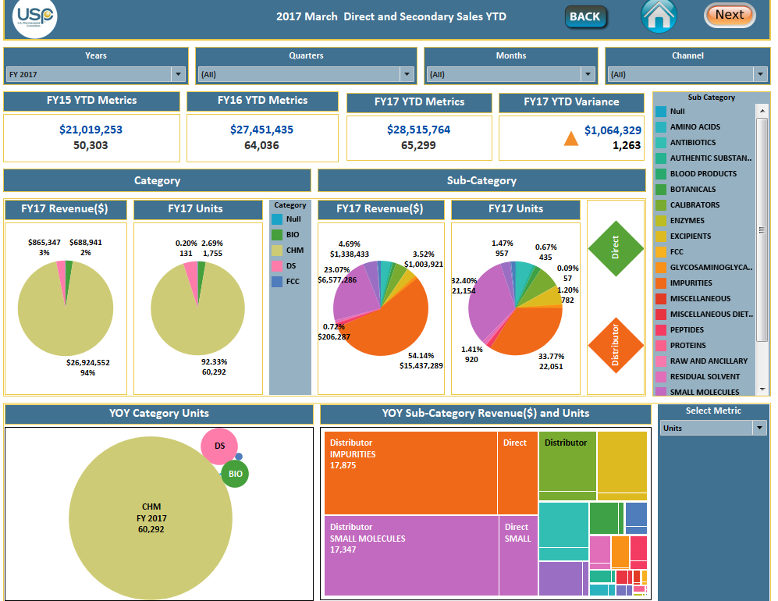

* **Data sources** – Secondary Data.
* **Buttons** – Home, Next, Back.
* **Filters** – Years, Quarters, Months Channels.
* **Measures**- Value in USD, Units.
* **Dimensions**-Channel, Date, Sub category, Category.
* **Calculations** – Current YTD, Previous YTD, YTD Variance.
* **Charts**- Pie chart, Tree map.
* **Actions:** Category, Sub Category, YOY Category Units, YOY Sub category Revenue Units ,Channel.
* **Parameter:** Select Metric

**Calculations**

**Current YTD:**

IF [Adjust date] <= [Adjust Fixed Date]

AND DATEDIFF ('year', [Adjust date], [Adjust Fixed Date]) =0

//OR DATEDIFF ('year', [Date], [Calculation1]) =1)

THEN [Value in Usd] END

**Adjust Date:**

DATEADD ('month', 6, [Date])

**Adjust Fixed Date:**

DATEADD ('month', 6, [Fixed date])

**Fixed Date:**

{FIXED: MAX ([Date])}

**Current YTD Units:**

IF [Adjust date] <= [Adjust Fixed Date]

AND DATEDIFF ('year', [Adjust date], [Adjust Fixed Date]) =0

//OR DATEDIFF ('year', [Date], [Calculation1]) =1)

THEN ([Units]) END

**Previous Current YTD:**

IF [Adjust date] <= [Adjust Fixed Date]

AND DATEDIFF ('year', [Adjust date], [Adjust Fixed Date]) =2

AND MONTH ([Adjust date]) <=MONTH ([Adjust Fixed Date])

//OR DATEDIFF ('year', [Date], [Calculation1]) =1)

THEN [Value in Usd] END

**Previous Current YTD Units:**

IF [Adjust date] <= [Adjust Fixed Date]

AND DATEDIFF ('year', [Adjust date], [Adjust Fixed Date]) =2

AND MONTH ([Adjust date]) <=MONTH ([Adjust Fixed Date])

//OR DATEDIFF ('year', [Date], [Calculation1]) =1)

THEN ([Units]) END

**Variance:**

**YTD**

ABS (ZN (RUNNING_SUM (sum ([Current YTD]))) - LOOKUP (ZN (RUNNING_SUM (SUM ([Previous Ytd]))), -1))

**Units:**

ABS (ZN (RUNNING_SUM (SUM ([Current YTD (Units)]))) - LOOKUP (ZN (RUNNING_SUM (SUM ([Previous Ytd (Units)]))), -1))

**Parameter Calculations:**

**Select Metric Size:**

Case [select Metric]

When 'U' then sum ([Units])

When 'R' then sum ([Value in Usd])

End

**Select Metric:**

Case [select Metric]

When 'U' then sum ([Units])

End

**Select Metric 2:**

Case [select Metric]

When 'R' then sum ([Value in Usd])

End

# **Category Trends**

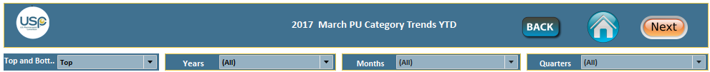

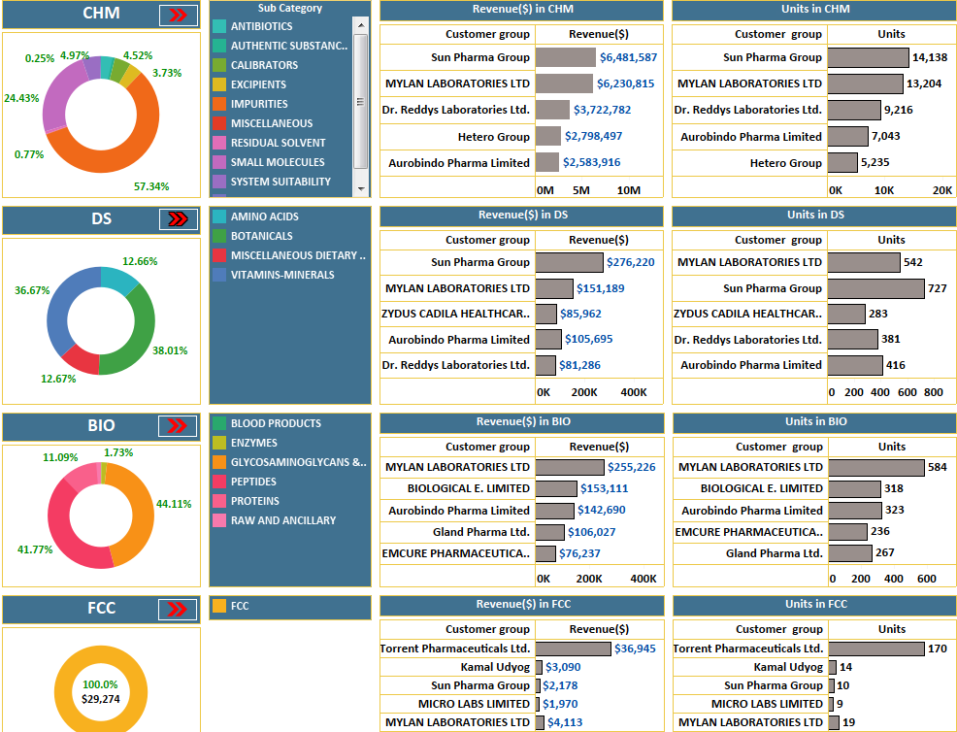

* **Data sources** - Secondary Data.
* **Buttons** – Home, Next, Back.
* **Filters** – Years, Quarters, Months, Channels, Top5 and Bottom5 Revenue and Top5 and Bottom5 Units.
* **Measures**- Value in USD, Units.
* **Dimensions**-Channel, Date, Category, Sub category.
* **Calculations** – Sum (Value in Usd), Sum (Units).
* **Charts** - Bars, Pie Chart.
* **Parameter –**Top and Bottom.

# **Chm Dashboard**



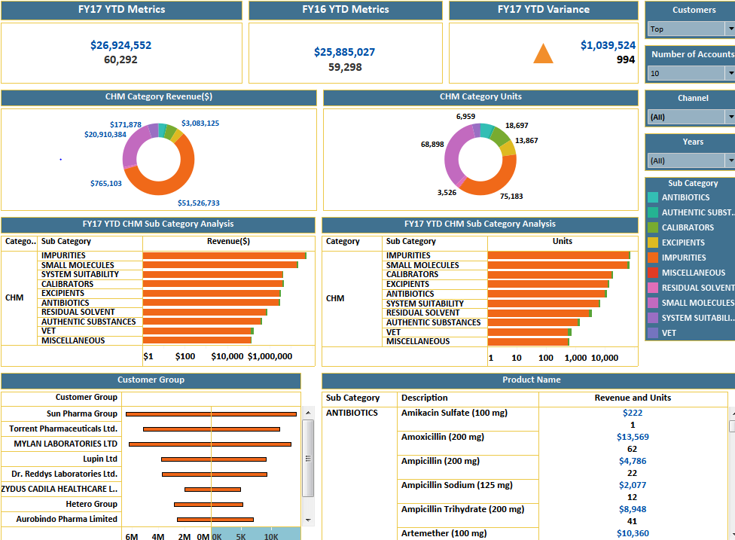

* **Data sources** - Secondary Data.
* **Buttons** – Home, Next, Back.
* **Filters** – Years, Quarters, Months, Channels, Customers Group, Number of Accounts, Category.
* **Measures**- Value in USD, Units.
* **Dimensions**-Channel, Date, Category, Sub category, Descriptions, Customer Groups.
* **Calculations** – Sum (Value in Usd), Sum (Units).
* **Charts** – Bars, Pie Chart.

**Calculations**

**Current YTD:**

IF [Adjust date] <= [Adjust Fixed Date]

AND DATEDIFF ('year', [Adjust date], [Adjust Fixed Date]) =0

//OR DATEDIFF ('year', [Date], [Calculation1]) =1)

THEN [Value in Usd] END

**Adjust Date:**

DATEADD ('month', 6, [Date])

**Adjust Fixed Date:**

DATEADD ('month', 6, [Fixed date])

**Fixed Date:**

{FIXED: MAX ([Date])}

**Current YTD Units:**

IF [Adjust date] <= [Adjust Fixed Date]

AND DATEDIFF ('year', [Adjust date], [Adjust Fixed Date]) =0

//OR DATEDIFF ('year', [Date], [Calculation1]) =1)

THEN ([Units]) END

**Previous Current YTD:**

IF [Adjust date] <= [Adjust Fixed Date]

AND DATEDIFF ('year', [Adjust date], [Adjust Fixed Date]) =2

AND MONTH ([Adjust date]) <=MONTH ([Adjust Fixed Date])

//OR DATEDIFF ('year', [Date], [Calculation1]) =1)

THEN [Value in Usd] END

**Previous Current YTD Units:**

IF [Adjust date] <= [Adjust Fixed Date]

AND DATEDIFF ('year', [Adjust date], [Adjust Fixed Date]) =2

AND MONTH ([Adjust date]) <=MONTH ([Adjust Fixed Date])

//OR DATEDIFF ('year', [Date], [Calculation1]) =1)

THEN ([Units]) END

**Variance:**

**YTD**

ABS (ZN (RUNNING_SUM (sum ([Current YTD]))) - LOOKUP (ZN (RUNNING_SUM (SUM ([Previous Ytd]))), -1))

**Units**

ABS (ZN (RUNNING_SUM (SUM ([Current YTD (Units)]))) - LOOKUP (ZN (RUNNING_SUM (SUM ([Previous Ytd (Units)]))), -1))

**Parameter –**Range, Customers.

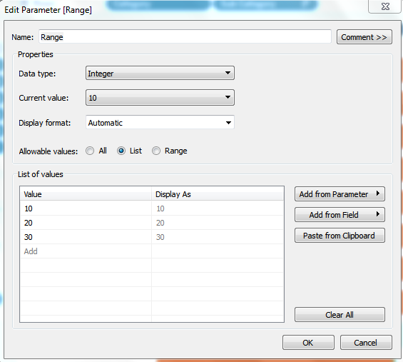

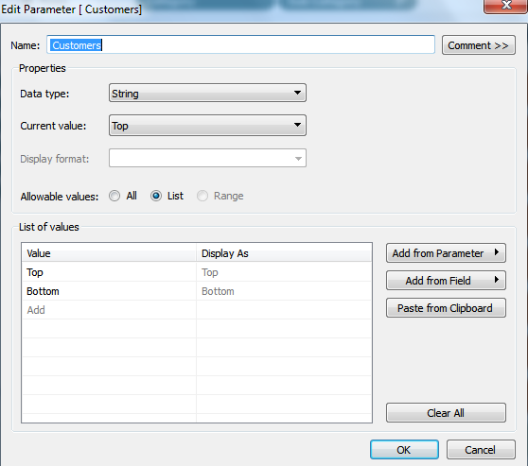

**Parameter Calculations:**

**Revenue Parameter:**

IF [Revenue # Units] = 'Revenue' OR [Revenue # Units] ='All' THEN SUM ([Value In Usd]) END

**Units Parameter:**

IF [Revenue # Units] = 'Units' OR [Revenue # Units] ='All' THEN SUM ([Units]) END

# **Bio DashBoards**



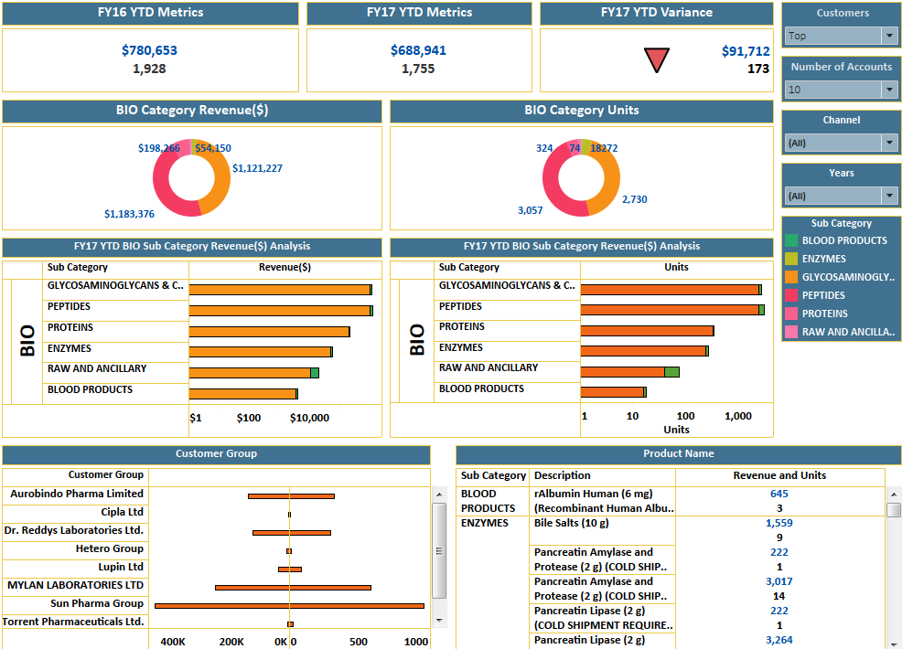

* **Data sources** - Secondary Data.
* **Buttons** – Home, Next, Back.
* **Filters** – Years, Quarters, Months, Channels, Customers Group, Number of Accounts, Category.
* **Measures**- Value in USD, Units.
* **Dimensions**-Channel, Date, Category, Sub category, Descriptions, Customer Groups.
* **Calculations** – Sum (Value in Usd), Sum (Units).
* **Charts** – Bars, Pie Chart.

**Calculations**

**Current YTD:**

IF [Adjust date] <= [Adjust Fixed Date]

AND DATEDIFF ('year', [Adjust date], [Adjust Fixed Date]) =0

//OR DATEDIFF ('year', [Date], [Calculation1]) =1)

THEN [Value in Usd] END

**Adjust Date:**

DATEADD ('month', 6, [Date])

**Adjust Fixed Date:**

DATEADD ('month', 6, [Fixed date])

**Fixed Date:**

{FIXED: MAX ([Date])}

**Current YTD Units:**

IF [Adjust date] <= [Adjust Fixed Date]

AND DATEDIFF ('year', [Adjust date], [Adjust Fixed Date]) =0

//OR DATEDIFF ('year', [Date], [Calculation1]) =1)

THEN ([Units]) END

**Previous Current YTD:**

IF [Adjust date] <= [Adjust Fixed Date]

AND DATEDIFF ('year', [Adjust date], [Adjust Fixed Date]) =2

AND MONTH ([Adjust date]) <=MONTH ([Adjust Fixed Date])

//OR DATEDIFF ('year', [Date], [Calculation1]) =1)

THEN [Value in Usd] END

**Previous Current YTD Units:**

IF [Adjust date] <= [Adjust Fixed Date]

AND DATEDIFF ('year', [Adjust date], [Adjust Fixed Date]) =2

AND MONTH ([Adjust date]) <=MONTH ([Adjust Fixed Date])

//OR DATEDIFF ('year', [Date], [Calculation1]) =1)

THEN ([Units]) END

**Variance:**

**YTD**

ABS (ZN (RUNNING_SUM (sum ([Current YTD]))) - LOOKUP (ZN (RUNNING_SUM (SUM ([Previous Ytd]))), -1))

**Units**

ABS (ZN (RUNNING_SUM (SUM ([Current YTD (Units)]))) - LOOKUP (ZN (RUNNING_SUM (SUM ([Previous Ytd (Units)]))), -1))

**Parameter –**Range, Customers.





**Parameter Calculations:**

**Revenue Parameter:**

IF [Revenue # Units] = 'Revenue' OR [Revenue # Units] ='All' THEN SUM ([Value In Usd]) END

**Units Parameter:**

IF [Revenue # Units] = 'Units' OR [Revenue # Units] ='All' THEN SUM ([Units]) END

# **Ds Dashboard**



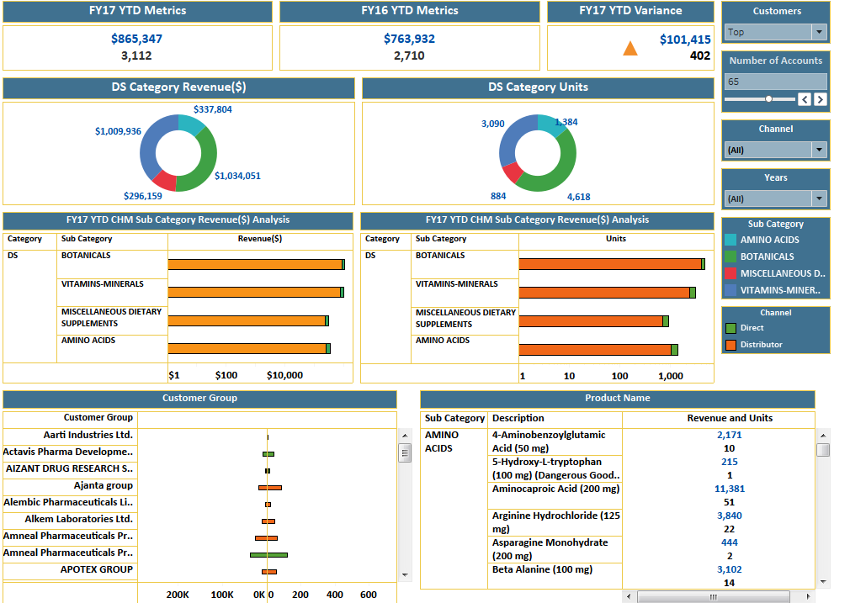

* **Data sources** - Secondary Data.
* **Buttons** – Home, Next, Back.
* **Filters** – Years, Quarters, Months, Channels, Customers Group, Number of Accounts, Category.
* **Measures**- Value in USD, Units.
* **Dimensions**-Channel, Date, Category, Sub category, Descriptions, Customer Groups.
* **Calculations** – Sum (Value in Usd), Sum (Units).
* **Charts** – Bars, Pie Chart.

**Calculations**

**Current YTD:**

IF [Adjust date] <= [Adjust Fixed Date]

AND DATEDIFF ('year', [Adjust date], [Adjust Fixed Date]) =0

//OR DATEDIFF ('year', [Date], [Calculation1]) =1)

THEN [Value in Usd] END

**Adjust Date:**

DATEADD ('month', 6, [Date])

**Adjust Fixed Date:**

DATEADD ('month', 6, [Fixed date])

**Fixed Date:**

{FIXED: MAX ([Date])}

**Current YTD Units:**

IF [Adjust date] <= [Adjust Fixed Date]

AND DATEDIFF ('year', [Adjust date], [Adjust Fixed Date]) =0

//OR DATEDIFF ('year', [Date], [Calculation1]) =1)

THEN ([Units]) END

**Previous Current YTD:**

IF [Adjust date] <= [Adjust Fixed Date]

AND DATEDIFF ('year', [Adjust date], [Adjust Fixed Date]) =2

AND MONTH ([Adjust date]) <=MONTH ([Adjust Fixed Date])

//OR DATEDIFF ('year', [Date], [Calculation1]) =1)

THEN [Value in Usd] END

**Previous Current YTD Units:**

IF [Adjust date] <= [Adjust Fixed Date]

AND DATEDIFF ('year', [Adjust date], [Adjust Fixed Date]) =2

AND MONTH ([Adjust date]) <=MONTH ([Adjust Fixed Date])

//OR DATEDIFF ('year', [Date], [Calculation1]) =1)

THEN ([Units]) END

**Variance:**

**YTD**

ABS (ZN (RUNNING_SUM (sum ([Current YTD]))) - LOOKUP (ZN (RUNNING_SUM (SUM ([Previous Ytd]))), -1))

**Units**

ABS (ZN (RUNNING_SUM (SUM ([Current YTD (Units)]))) - LOOKUP (ZN (RUNNING_SUM (SUM ([Previous Ytd (Units)]))), -1))

**Parameter –**Range, Customers.





**Parameter Calculations:**

**Revenue Parameter:**

IF [Revenue # Units] = 'Revenue' OR [Revenue # Units] ='All' THEN SUM ([Value In Usd]) END

**Units Parameter:**

IF [Revenue # Units] = 'Units' OR [Revenue # Units] ='All' THEN SUM ([Units]) END

# **Fcc dashboard**



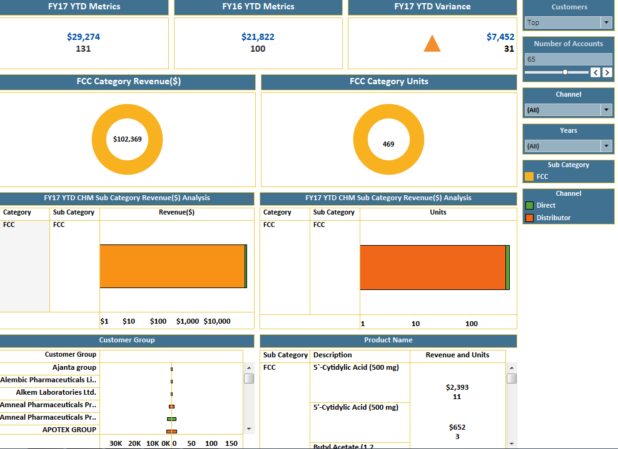

* **Data sources** - Secondary Data.
* **Buttons** – Home, Next, Back.
* **Filters** – Years, Quarters, Months, Channels, Customers Group, Number of Accounts, Category.
* **Measures**- Value in USD, Units.
* **Dimensions**-Channel, Date, Category, Sub category, Descriptions, Customer Groups.
* **Calculations** – Sum (Value in Usd), Sum (Units).
* **Charts** – Bars, Pie Chart.

**Calculations**

**Calculations**

**Current YTD:**

IF [Adjust date] <= [Adjust Fixed Date]

AND DATEDIFF ('year', [Adjust date], [Adjust Fixed Date]) =0

//OR DATEDIFF ('year', [Date], [Calculation1]) =1)

THEN [Value in Usd] END

**Adjust Date:**

DATEADD ('month', 6, [Date])

**Adjust Fixed Date:**

DATEADD ('month', 6, [Fixed date])

**Fixed Date:**

{FIXED: MAX ([Date])}

**Current YTD Units:**

IF [Adjust date] <= [Adjust Fixed Date]

AND DATEDIFF ('year', [Adjust date], [Adjust Fixed Date]) =0

//OR DATEDIFF ('year', [Date], [Calculation1]) =1)

THEN ([Units]) END

**Previous Current YTD:**

IF [Adjust date] <= [Adjust Fixed Date]

AND DATEDIFF ('year', [Adjust date], [Adjust Fixed Date]) =2

AND MONTH ([Adjust date]) <=MONTH ([Adjust Fixed Date])

//OR DATEDIFF ('year', [Date], [Calculation1]) =1)

THEN [Value in Usd] END

**Previous Current YTD Units:**

IF [Adjust date] <= [Adjust Fixed Date]

AND DATEDIFF ('year', [Adjust date], [Adjust Fixed Date]) =2

AND MONTH ([Adjust date]) <=MONTH ([Adjust Fixed Date])

//OR DATEDIFF ('year', [Date], [Calculation1]) =1)

THEN ([Units]) END

**Variance:**

**YTD**

ABS (ZN (RUNNING_SUM (sum ([Current YTD]))) - LOOKUP (ZN (RUNNING_SUM (SUM ([Previous Ytd]))), -1))

**Units**

ABS (ZN (RUNNING_SUM (SUM ([Current YTD (Units)]))) - LOOKUP (ZN (RUNNING_SUM (SUM ([Previous Ytd (Units)]))), -1))

**Parameter –**Range, Customers.





**Parameter Calculations:**

**Revenue Parameter:**

IF [Revenue # Units] = 'Revenue' OR [Revenue # Units] ='All' THEN SUM ([Value In Usd]) END

**Units Parameter:**

IF [Revenue # Units] = 'Units' OR [Revenue # Units] ='All' THEN SUM ([Units]) END

# **What if Analysis**



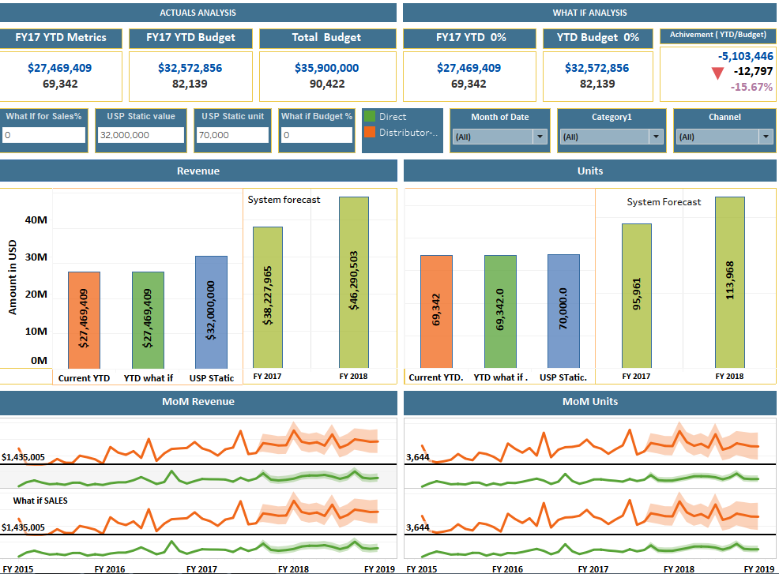

* **Data sources** - Primary Data.
* **Buttons** – Home, Next, Back.
* **Filters** – Years, Quarters, Category.
* **Forecast Analysis**- Revenue, Units.
* **Measures**- Value in USD, Units.
* **Dimensions**-Channel, Date, Category.
* **Calculations** – Current YTD, Current YTD Units, YTD Budget, YTD Budget Units, Budget in Dollars, Budget in Units, Current YTD What if, Current YTD What if Units, YTD Budget What if,

YTD Budget Units What if, What if Variance YTD, What if Variance Units, What if Variance (copy)-1, YTD what if, AVG USP Static

* **Charts**- Bars, line.

**Calculations:**

**Current YTD:**

IF [Adjust date] <= [Adjust Fixed Date]

AND DATEDIFF ('year', [Adjust date], [Adjust Fixed Date]) =0

//OR DATEDIFF ('year', [Date], [Calculation1]) =1)

THEN [Value in Usd] END

**Adjust Date:**

DATEADD ('month', 6, [Date])

**Adjust Fixed Date:**

DATEADD ('month', 6, [Fixed date])

**Fixed Date:**

{FIXED: MAX ([Date])}

**Current YTD Units:**

IF [Adjust date] <= [Adjust Fixed Date]

AND DATEDIFF ('year', [Adjust date], [Adjust Fixed Date]) =0

//OR DATEDIFF ('year', [Date], [Calculation1]) =1)

THEN ([Units]) END

**YTD Budget:**

SUM (IF [Date] <= TODAY () THEN [YTD budget Dollars] end)

**YTD Budget Units:**

SUM (IF [Date] <= TODAY () THEN [YTD budget Units] end)

**Current YTD What if:**

[Current YTD]*(1+ [What If for Sales]/100)

**Current YTD What if Units:**

[Current YTD (Units)]*(1+ [What If for Sales]/100)

**YTD Budget What if:**

[YTD Budget]*(1+ [What if Budget]/100)

**YTD Budget Units What if :**

[YTD Budget (units)]*(1+ [What if Budget]/100)

**What if Variance YTD:**

SUM ([current YTD what if])-[Budget (Budget YTD v2.0 BR)]. [YTD Budget What if]

**What if Variance Units:**

SUM ([current YTD Units what if])-[Budget (Budget YTD v2.0 BR)]. [YTD Budget Units What if]

**What if Variance copy-1:**

SUM ([current YTD what if])/ [Budget (Budget YTD v2.0 BR)]. [YTD Budget What if]

**Parameters:**

**What if Budget**

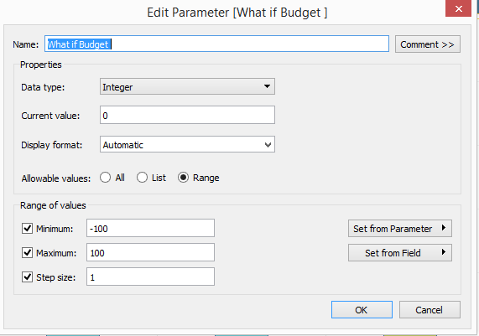

**What If for Sales**

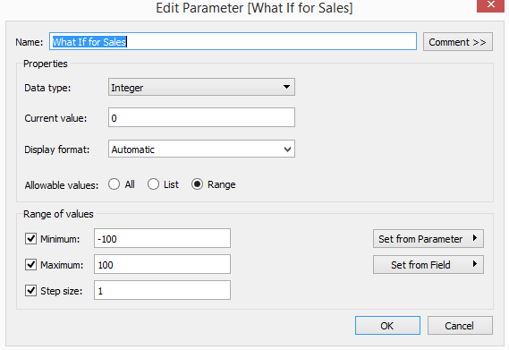

**USP Static unit**

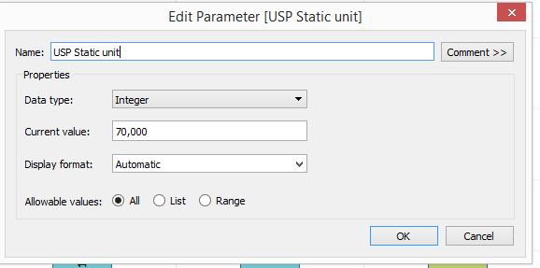

**USP Static value**

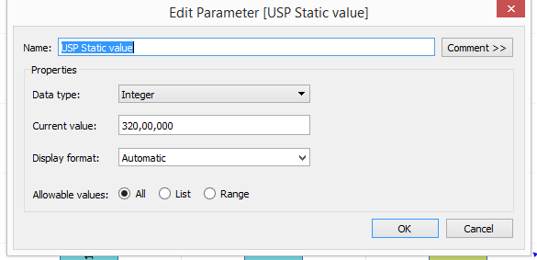

# **Unique Customer Analysis**

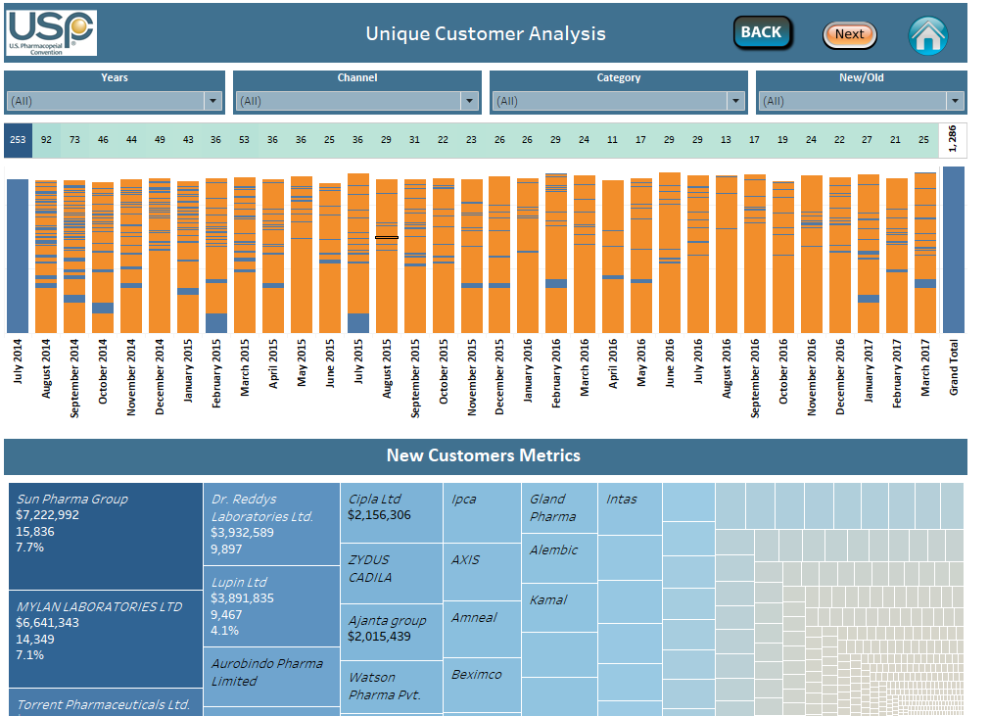

* **Data sources** – Secondary Data.
* **Buttons** – Home, Next, Back.
* **Filters** – Years, Channel, Category and New/Old.
* **Measures**- Value in USD, Units.
* **Dimensions**-Channel, Date, Category.
* **Calculations** – Calculation1, Sum (Value in Usd), Sum (Units), New? And Countd(customer group)
* **Charts**-Stacked Bars, Tree maps and Text.

**Calculations:**

**Calculation1:**

**{FIXED [Customer Group]: MIN ([Date])}**

**New?**

**If running sum (countd ([Customer Group]))>=2 then 'not new'**

**Else 'new'**

**End**

# **Monograph mapping**

* **Data sources** – Secondary Data.
* **Buttons** – Home, Next, Back.
* **Filters** – Years, Channel, Category and Description.
* **Measures**- Value in USD, Units.
* **Dimensions**-Channel, Date, Category, Customer Group, item no, Description.
* **Calculations** – Sum (Value in Usd), Countd(customer group)
* **Charts**-Stacked Bars, Tree maps and Text.
* **Columns**: Customer Group
* **Rows:** Sum (Units)
* **Tooltips:** Valve in USD, Units.

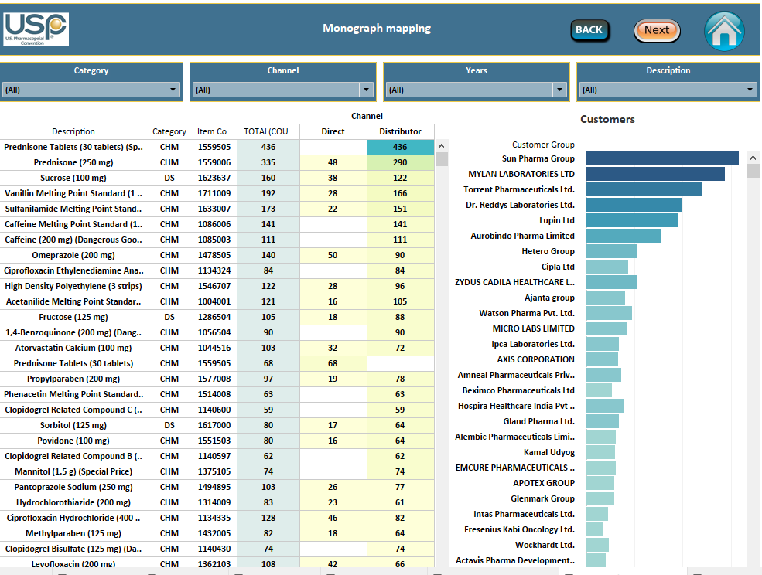

# **MONOGRAPH RS MAPPING**

* **Data sources** – Sheet 1 MG RS Mapping
* **Buttons** – Home, Next, Back.
* **Filters** – Years, Customer Group, Category and Mono Title.
* **Measures**- Value in USD, Units.
* **Dimensions**-Channel, Date, Category, Customer Group, item no, Description.
* **Calculations** – Sum (1.Fixed), Countd(Rs Items)
* **Charts**-Stacked Bars, Tree maps and Text.
* **Columns**: Cntd (Rs item), Sum (1.fixed).
* **Rows:** Customer Group, Mono Num, Mono Title, Customer Group, Category.
* **Tooltips:** Valve in USD, Units.

**Calculations:**

**1. Fixed:**

{FIXED [Mono Num (Xxusp Mars T Mono2Rs Rpt V)]: COUNTD ([Rsitem Num (Xxusp Mars Erp Ont Sales)])}

**Countd (Rs Items)**

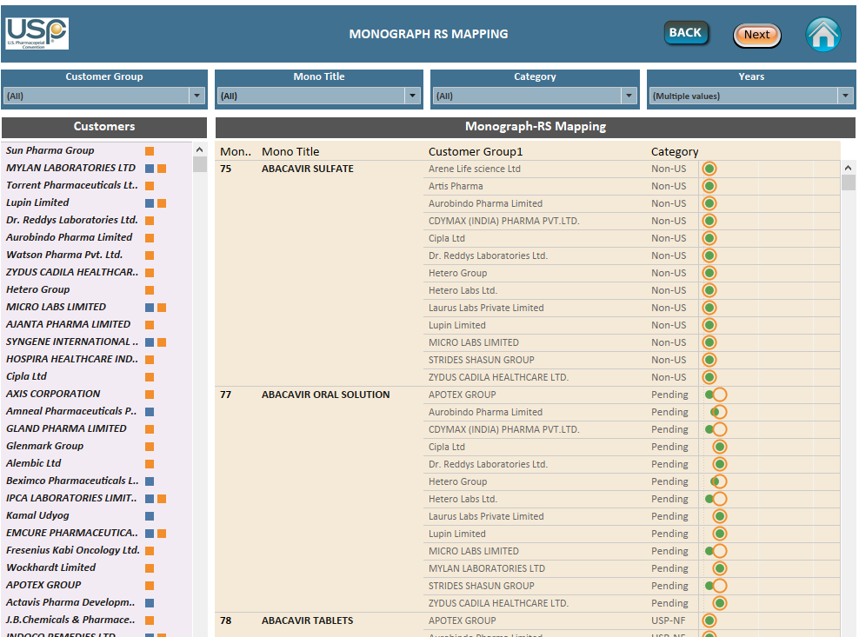

# **Detailed Monograph Mapping**

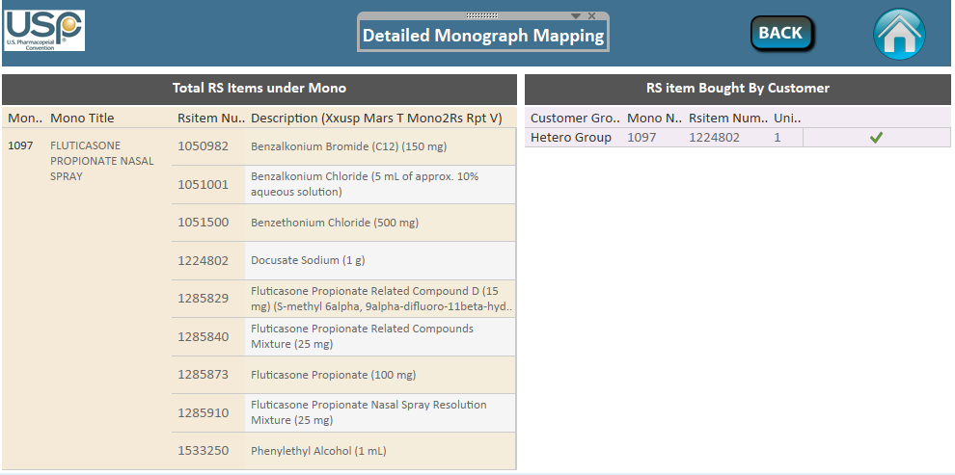

* **Data sources** – Sheet 1 MG RS Mapping
* **Buttons** – Home, Back.
* **Dimensions**- Customer Group, RS item no, Description.
* **Calculations** – Sum (1.Fixed), Countd(Rs Items)
* **Charts**- Text.
* **Rows:** Mono Num, Mono Title, Customer Group, RS item no, Description,.
* **Tooltips:** Sum (Units).

How to add new data for existing excels:

1. Add the new data to existing data sources (excels).
2. On the start page, under **Connect**, click **Excel**.
3. Select the Excel workbook you want to connect to, and then click **Open**
4. Refresh the data sources after adding data.
5. Do all the things in data pane.

**Data sources:**

**Direct Data Cleaned_V2.0 BR (primary)**

**Direct data+ distributor (secondary) _v2.0 BR (secondary)**

**PU_Sub_Categories_v2.0 BR**

**MG_RS Mapping**

**Budget YTD v2.0 BR**

**Add new data to these excels (Mentioned above).**

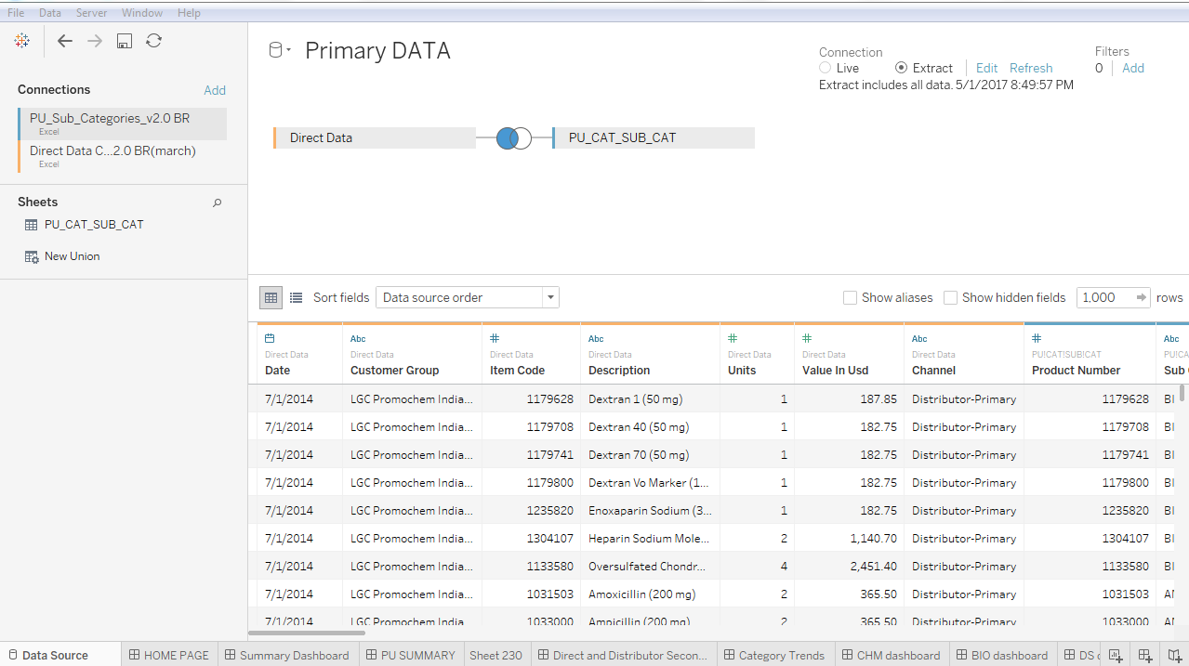

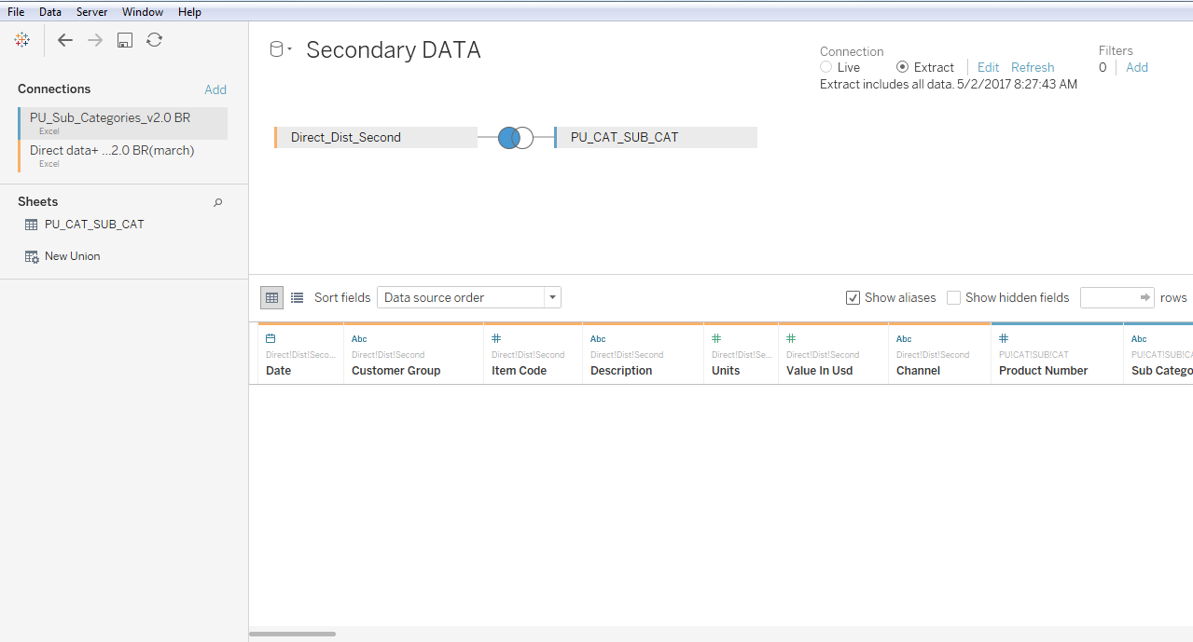

How to publish in tableau reader:

Open tableau reader and choose saved twbx file (dashboards).

Click on Open a Workbook.

Choose the work book which is saved.

Automatically it opens the dashboards.

Share the path of saved dashboard to all reader users.